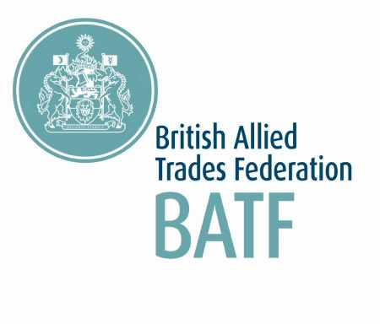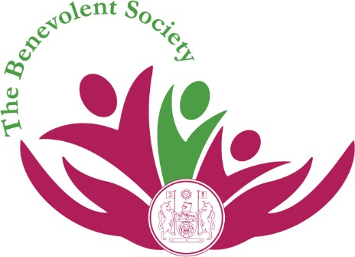

Charity funding application
The British Allied Trades Federation (BATF) plan to donate £30,000 over 3 years (at a rate of £10,00 per annum) to charities chosen by BATF members. Applications will be shortlisted by The Benevolent Society Board of Trustees and the recipient(s) of the funding will be decided by the BATF Board of Directors and Trustees of The Benevolent Society. More than one charity may be chosen to receive the funding, in this case the funding will be shared.
Please note that whilst The Benevolent Society will be administering the applications only, the donations are fully funded by BATF.
All BATF members are encouraged to apply. Please complete and return the below application form to Laura Banner laura.b.banner@gmail.com by Friday 14th February 2020. Successful applicants will be notified in early April. When we inform the Charity, we would like to do this in conjunction with you as that applicant but please indicate which of the three options below suits you:

I would like to be informed and involved in the donation.

I would like to be informed only and not be involved in the donation.

I would rather not be contacted again re this and am happy for all to proceed without informing or involving me any further.

Your name:
Your company name:
Your chosen charity (including Charity Registration Number if known):
Point of contact at the charity (if available):

Charity’s website (if applicable):

Please describe in less than 400 words what the charity does:

Please indicate the amount of funding required and how it will be used:

Please indicate how you know the charity/if you have any personal experience of the charity and why you think it deserves the funding:

If the Trustees of the Benevolent Society have any questions that they would like to ask you regarding your application is there a telephone number and/or email address that you could be contacted on please?

Telephone number

Email address

